# Python: Exercise on Lists and Strings

**Name: Mark Lopes**

**Roll No: 9913**

**S.E Comps_A Batch C**

Q1. Given a list of strings, return the count of the number of strings where the string length is 2 or more and the first and last chars of the string are the same.

def count_string(list):  
 count = 0  
 for string in list :  
 if len(string)>=2 and string[0]==string[-1]:  
 count += 1  
 return count  
  
  
list1=["hello","mam","u","yuy","hf fh"]  
final_count=count_string(list1)  
print("The count is:")  
print(final_count)

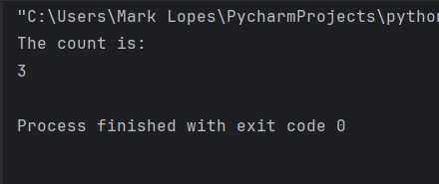

Q2. Given a list of strings, return a list with the strings in sorted order, except group all the strings that begin with &#39;x&#39; first.

def string_sort(strings_list):  
 # Initialize empty lists  
 starts_with_x = []  
 does_not_start_with_x = []  
  
 # Separate the strings into two groups  
 for string in strings_list:  
 if string and string[0] == 'x':  
 starts_with_x.append(string)  
 else:  
 does_not_start_with_x.append(string)  
  
 # Sort both groups  
 starts_with_x.sort()  
 does_not_start_with_x.sort()  
  
 # Combine the sorted lists  
 result = starts_with_x + does_not_start_with_x  
  
 return result  
  
  
list=["xampp","pycharm","vs_code","xpfs","area"]  
sorted_list = string_sort(list)  
print(sorted_list)

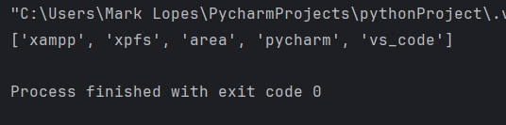

Q3. Given two lists sorted in increasing order, create and return a merged list of all the elements in sorted order. You may modify the passed in lists. Ideally, the solution should work in &quot;linear&quot; time, making a single pass of both lists.

def sort_both(s1,s2):  
 final_sort=s1+s2  
 final_sort=sorted(final_sort)  
 return final_sort  
  
  
list1 = ["d","t","c"]  
list2 = ["z","b","a"]  
  
print(sort_both(list1,list2))

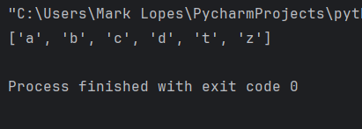

Q4. Given a string s, return a string made of the first 2 and the last 2 chars of the original string, so &#39;spring&#39; yields &#39;spng&#39;. However, if the string length is less than 2, return instead the empty string.

def q4(s):  
 if len(s)<2:  
 return ""  
 string = s[:2] + s[-2:]  
 return string  
  
  
test_string="Mark Lopes"  
print(q4(test_string))

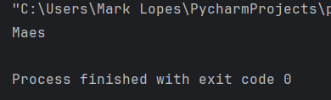

Q5. Given a string s, return a string where all occurences of its first char have been changed to &#39;*&#39;, except do not change the first char itself.

test_string = "engineering"  
print(test_string[0]+test_string[1:].replace(test_string[0],'*'))

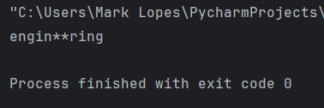

Q6. Given strings a and b, return a single string with a and b separated by a space &#39;&lt;a&gt; &lt;b&gt;&#39;, except swap the first 2 chars of each string.

s1 = input("Enter first string\n")  
s2 = input("Enter second string\n")  
  
print(s2[0]+s1[1:]+" "+s1[0]+s2[1:])

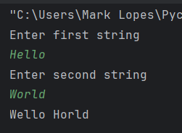

Q7. Given a string, find the first appearance of the substring &#39;not&#39; and &#39;bad&#39;. If the &#39;bad&#39; follows the &#39;not&#39; replace the whole &#39;not&#39;...&#39;bad&#39; substring with &#39;good&#39;. Return the resulting string.

def check_string(s):  
 if (s.find('not')!=-1 and s.find('bad')!=-1):  
 print(s[:s.find('not')]+"good")  
  
  
test_string=input("Enter first string: ")  
check_string(test_string)

